 VETERAN FOURS HEAD 2026 
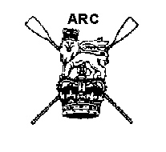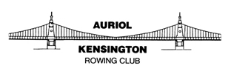

SAFETY AND MARSHALLING INSTRUCTIONS
FOR CAPTAINS, COXSWAINS AND STEERS

The Veteran Fours Head will be rowed on Sunday 22 November 2026, starting at 13.30, from the University Stone, Chiswick, to the Putney Pier, Putney, on the ebb tide.

SAFETY IS THE RESPONSIBILITY OF ALL.
A crew that is unaware of these instructions or simply ignores them is a danger to itself and all other crews. A crew that is considered dangerous will be prevented from racing or, if acting dangerously during the race, risks a time penalty or disqualification.

It is the responsibility of club captains to ensure all their coxes and steers:
- Are competent to be ‘masters’ of the vessel,
- Have read and know the relevant parts of the Tideway Code and
- As well as having read these instructions also understand them.
- All crews must make their own risk assessment on the day of the race, taking into account their personal circumstances and fitness. All participants must be aware of their responsibility to themselves and others with regards to their ability to take part safely in the conditions as they find them on the day of the event.

All crews must comply with the regulations laid down in the British Rowing Rules of Racing and Row Safe Code. In particular, club captains must ensure that all competitors are aware of sections 3.6 and 7.3 of Row Safe, regarding swimming ability and safety aids.

All crews are to be aware of the race abandonment plan and emergency incident management plans that are at the end of this document. In addition, please take heed of the bad weather procedure document on the website and check in the week of the race for weather updates on the website and via X (Twitter) (@vetfourshead). All crews must be aware of the PLA Flag Warning system for the Ebb tide; the current flag status is also shown on the race website. Any crews or clubs that participate in private racing in the event of a race cancellation or abandonment will be reported to the PLA, who may see fit to take action against the club(s) involved.

It is the responsibility of individual crews to ensure that their equipment fully meets the requirements of the British Rowing Row Safe Code, including issues of buoyancy, the integrity of closed compartments, bow balls, heel restraints and steering gear. The Race Committee Chair will decide appropriate penalties for crews found failing to comply with the code; these will include disqualification for serious breaches.
Should a crew have a mechanical breakdown or steering failure it is essential that the crew stop racing and notify an official of the problem. It important that crews do not put themselves and others at risk by trying to finish the race with defective steering.
If a member of the crew should fall out of the boat, the crew must stop and help. Shout loudly to any crew behind to warn them. Following crews must take avoiding action and all crews must alert rescue craft immediately.
It is recommended, but is not mandatory, that crews carry a mobile phone on board. If the emergency services [dial 999/119] need to be called, either using a mobile phone held by the crew or a spectator’s phone, the services of the Coastguard should be requested when speaking to the emergency services operator.

Eight safety launches will be in position along the course. Anyone in need of assistance should notify a marshal or observer who will be able to summon help on his/her radio. Crews should use the International Safety Signal (slowly and repeatedly raising and lowering arms outstretched to either side) when asking for help.

LOCATIONS OF SAFETY BOATS
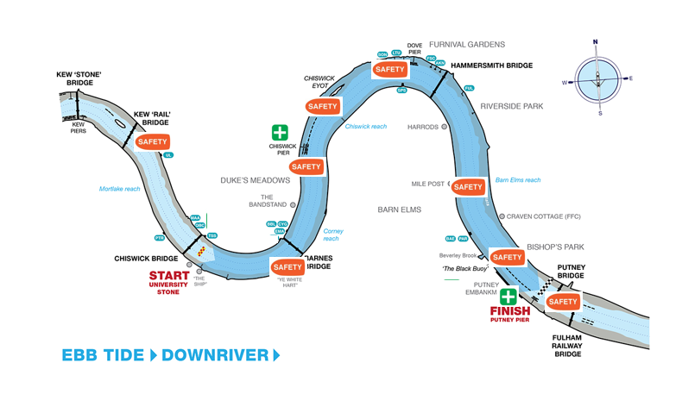

Safety launches will follow the last boat(s) back to Chiswick Bridge. This will be done with reasonable attention as to which is the last boat on the river returning to Chiswick. Any crews that stop and disembark on the way back, but then subsequently re-boat, will not be part of the safety roll-up of the race.
It is advised that, in the interests of spectator and bystander safety, supporters and coaches following the race on bicycles take due care.
Para medics will be available at:
- Chiswick Pier (dedicated launch)
- Putney (Embankment by London Rowing Club).
The river is closed to other river users from 12.30 until 16.30, (see Notice to Mariners U29-26 of 2026). Prior to and post the river closure normal navigational rules apply and must be known and obeyed. During the race crews must follow the race rules, but this does not absolve a crew from its responsibility to navigate a safe course at all times.
Normal Tideway navigation rules must be obeyed except where specified by these instructions during the river closure. Crews seeking further clarification should consult the PLA or TRRC websites, or ask club or regional water safety advisors.
British Rowing insurance for the event will only be valid for UK residents defined as being resident for six [6] months or more. Rules of Racing 4.4. Competitors aged 80 and over are covered against third party liability but not for personal accident.
Crews affiliated to any rowing association outside of Britain that is recognised by British Rowing or World Rowing do not have to register with British Rowing but must have third-party liability insurance.

Marshalling Instructions

Numbers
Number collection
Numbers will be delivered by Friday 20 November and will be available at designated collection points on the morning of the race. Please collect your number before going afloat for the race.

IMPORTANT: Crews must ensure that BROE is showing the correct host club for their boat by 12.00 noon on Thursday 19 November

Crews boating from Putney collect their numbers from VESTA ROWING CLUB
Crews boating from Hammersmith collect their numbers from SONS OF THE THAMES
Crews boating from the Civil Service Boathouse (aka Cygnet/Barnes Bridge Ladies) should go direct to their host clubs, where their numbers will be waiting. Numbers for Brentford BC will also be at the Civil Service Boathouse.
Crews boating from Tideway Scullers School and all clubs upstream of Chiswick Bridge collect their numbers from TIDEWAY SCULLERS SCHOOL
Crew changes can be made up until 10.00 using the BROE online system.

Collection point | Host clubs
Vesta Rowing Club | Thames, Barn Elms, Crabtree, Imperial College, King’s College School, London, Parr’s Priory, Putney High School, Vesta, Westminster
Sons of the Thames | Sons of the Thames, Auriol Kensington, Fulham Reach, Furnivall
Civil Service (Barnes Bridge Ladies/Cygnet) | Barnes Bridge Ladies, Cygnet
Tideway Scullers School | Tideway Scullers School, Mortlake Anglian & Alpha, Putney Town, Quintin, Twickenham, University of London

Displaying numbers
Crews will be issued with one Empacher number plate and two numbers.
The Empacher number plate must be securely affixed to the bow of the boat. Please avoid using a screw, which can damage the number and use tape if needed. Crews without a bow number cannot be guaranteed a finishing time.

One number must be securely fastened, at least at each corner, preferably with four safety pins – to the back of the bow person (NOT the cox) so as to be visible when racing (i.e. on racing kit).
The second number should be fixed to the back of the bow person (NOT the cox) so as to be visible in transit and when marshalling prior to the race (i.e. on warm-up kit).

Number return
After the race, Boat numbers must be returned undamaged, or a charge of £20 will be incurred, or by
2 December if sent by post.

On the day, numbers can be returned to the boxes at the number collection points. The numbers will then be picked up between 22-24 November.
The Treasurer will contact crews by e-mail that have not returned their number on 3 December to arrange payment.

Boating
Crews must not boat unless their equipment is in full working order.
Crews are advised to boat so as to reach their marshalling position in good time. It is the absolute responsibility of crews and their captains to ensure that this happens.

Hammersmith Bridge Navigation
Work is taking place on Hammersmith Bridge that will affect navigation. As per the NTM U37-26 parts of the bridge are closed to navigation. The reduced width will be marked with a diamond shape split vertically into two equilateral triangles. There will be sufficient room to navigate through Arch 3 in single file but care must be taken approaching the bridge and there must be no stopping within 100 meters past the bridge.
Red half indicating area closed to navigation
White half indicating area open to navigation

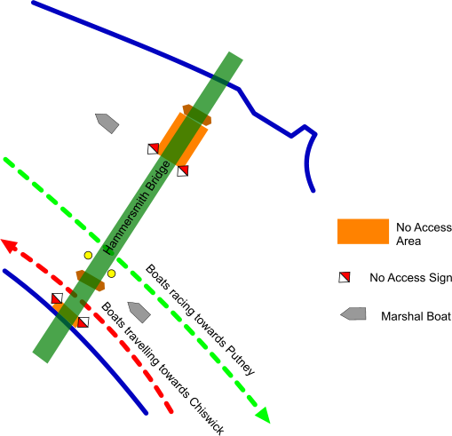

Marshalling positions
All crews must be in their marshalling positions by 13.20. No crews may ‘slot in’ to their divisions by boating late. Any crew doing so risks a time penalty or disqualification.
Crews must pay due attention to other boats and marshals’ launches to avoid collisions during marshalling.
Crews will assemble in four divisions:
- Division 1 (crew numbers 1 to 65) will marshal on Middlesex between Chiswick Quay Marina and the University of London boathouse, with bows pointing upstream and blades in contact with the bank (if safe) Crew 1 will be just upstream of Chiswick Quay Marina.
- Division 2 (crew numbers 66 to 140) will marshal on Surrey between Mortlake Steps and 100m downriver of Kew ‘Rail’ Bridge (just outside the Restricted Zone), with bows pointing upstream and blades in contact with the bank (if safe) Crew 66 will be just upstream of Mortlake Steps.
- Division 3 (crew numbers 141 to 205) will marshal on Middlesex between the green buoy above Barnes Bridge and Tideway Scullers School, with bows pointing upstream and blades in contact with the bank if safe Crew 205 will be just downstream of Tideway Scullers School, and crew 141 will be the nearest to Barnes Bridge. Crews will proceed through Chiswick Bridge when directed by the marshals after the departure of Division 1 and will take up the positions vacated by the crews in Division 1.
- Division 4 (crew numbers 206 to 280) will marshal on Surrey below Chiswick Bridge. Marshalling will be the same as for Division 3, i.e. the highest-numbered crew (crew 280) will be nearest to Chiswick Bridge and the division will move upstream after the departure of Division 2 as directed by the marshals, the highest-numbered crew being opposite the University of London boathouse.
Crews marshalling near Chiswick, Kew and Barnes Bridges are to comply with the 75m exclusion zones.

MAP OF MARSHALLING POSITIONS
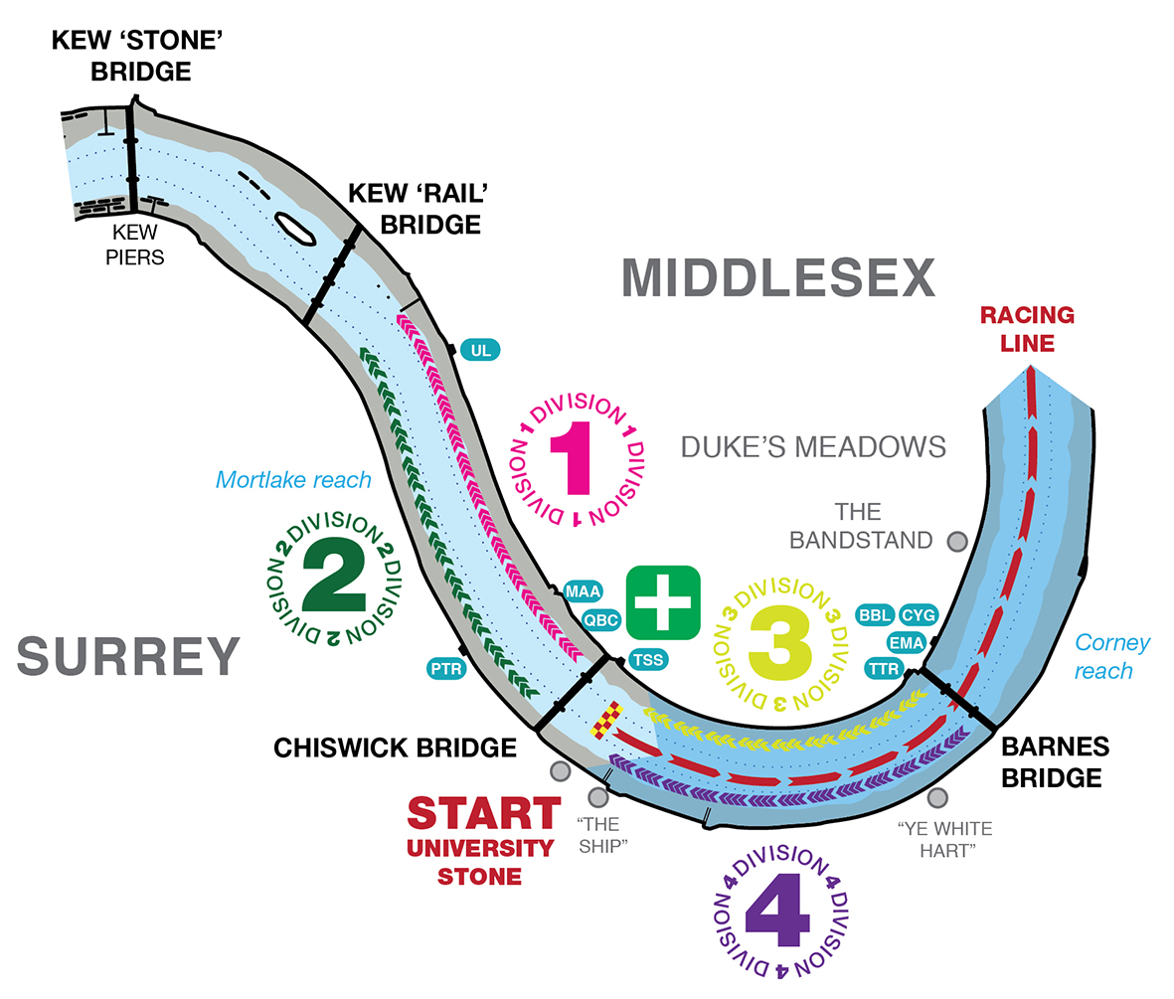

Once established in their marshalling positions, crews must keep in single file in line astern with their bows pointing upstream and keep as close to the bank as possible. Boats must maintain their position against the tide and neither allow themselves to become bunched together or allow gaps to develop between adjacent crews.
Crews must not row at or above race pressure between Barnes and Kew bridges after 12.45 unless specifically directed by a marshal or observer. Crews that are seen to contravene this instruction may receive a time penalty.
After 13.20 late crews must wait below Chiswick Bridge on Surrey at the end of Division 4. Under no circumstances should crews attempt to cross the river after 13.20 unless instructed to do so by a marshal.

The start of the race
The race will start on time and without reference to absentees.
Five minutes prior to the start, marshals will issue a verbal notice to crews. Crews in Division 1 should remove non-racing clothing.
On instructions from marshals, crews will turn, taking their bows out into the centre of the river. Do not ‘spin turn’ close in to the shore.
Crews will then proceed downstream to the start in numerical order leaving 1–2 lengths of clear water between crews.
Crews must pass through the centre span of Chiswick Bridge.
Crews will receive the instruction ‘[Number] … Go!’ from the Starter and timing will start at the University Stone.
Division 2 crews will be instructed to turn in order that they are ready to follow the last crews of Division 1 down to the start line. The same will apply for Divisions 3 and 4. Crews should remain vigilant and ensure they are ready to turn when required.

During the race
Coxswains and steers should maintain what they consider to be their best course, but MUST give way to overtaking crews by moving out of the stream. Crews must not go inside any navigation buoys and must go through the centre arch of bridges. Umpires will be posted at points along the course, and failure to observe these rules may result in time penalties, or, in extreme cases, lead to disqualification. Crews wishing to register an objection must do so to the Race Committee Chair within 30 mins of the last crew crossing the finish. Please call Luke Howells on 07773 849505 if you wish to lodge an objection or go to the Chiswick Pier House (The Pier House, Corney Reach Way, London W4 2UG) No objections of this nature will be considered after the results have been announced.

After the race: the finish area
To ensure a finish time is recorded and to avoid disqualification, all crews must approach the finish on the Middlesex side of the moored boats at Putney, keeping a safe distance from the boats and from the Black Buoy. CARE MUST BE TAKEN TO KEEP A GOOD LOOK OUT at this stage of the race, when tired and nearly finished.
Crews must not easy on the finish line at Putney Pier, but must paddle down through Putney Bridge and Fulham Railway Bridge then turn towards the Surrey bank
The instructions of marshals at the finish must be quickly and accurately adhered to.
Crews are not to attempt to move through Arch 5 at Putney Bridge nor attempt to move inside the Pier.

After the race: returning to your boathouse
Crews should proceed on the Surrey side of Putney Bridge and of the moored boats, paying due attention to crews disembarking at Putney.
Crews returning to boathouses above Putney should stay on the Surrey shore as close as is safe and practicable to the bank and must not row two abreast at all, unless overtaking. Crews returning to Hammersmith may cross above Hammersmith Bridge at the direction of a marshal/observer only.
After the last racing crew has passed Chiswick Pier crews returning to boathouses above this point may cross to Middlesex at the Chiswick Steps crossing. However, if crews are still racing, returning crews must remain on Surrey and only cross under the instruction of a marshal.
Above all, crews returning to their boathouses must not impede crews racing and must accordingly give way to these crews. Failure to do so may result in a penalty or disqualification.

Circulation Pattern at the Finish
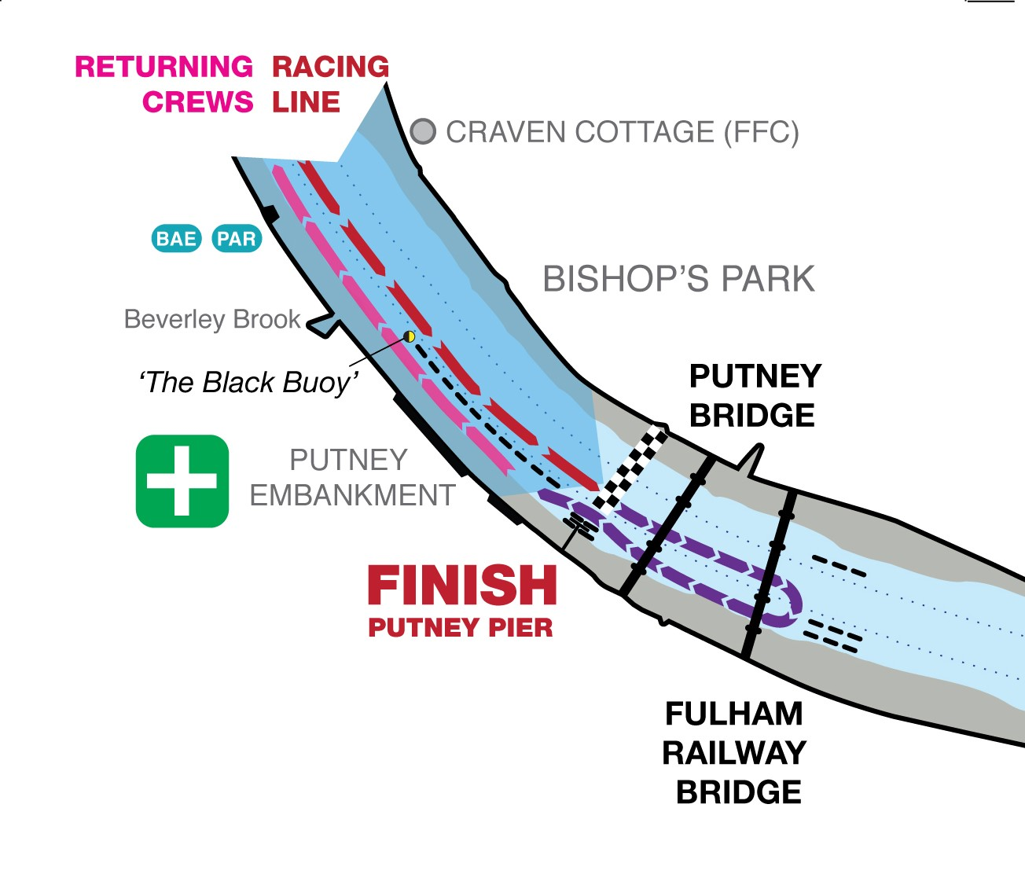

Environmental Impact
Competitors are reminded to consider their environmental impact and use reusable bottles and cups. You must properly dispose of all rubbish, including taking this home if appropriate facilities are not readily available.

General information
The Veteran Fours Head is run for the benefit of the competitors. It endeavours to provide an enjoyable and fair race for all. Please obey marshals’ instructions at all times; however, this does not negate your responsibility as masters of the vessel for the safe navigation of your craft.

For the purposes of the event’s insurance, the event is deemed to commence at 12.30 and ends at 16.30.
Provisional Results will be posted as soon as possible after the race on the web site http://vet4shead.com/

Abandonment Plan and Emergency Incident Management

If the race has to be abandoned at any time while crews are marshalling or racing, the following procedure will apply and be strictly adhered to:

Crews, on hearing instructions from marshals/umpires will immediately STOP. They will wait to be instructed on how and where to proceed by a marshal. They must maintain a sharp lookout for other crews in the vicinity, who may not have heard or seen the warnings and are continuing with marshalling or racing. If necessary they must move to avoid any collision with such a crew.

Marshals will wait for instructions from the Chief Marshal, who will be in constant communication with the Safety Advisor, and once the cause and location of the problem has been determined she will proceed to put the abandonment plan into operation.

Depending on where crews have boated, whether or not the race has started and the number of crews still being marshalled, they may be asked to either paddle lightly upstream under the direction of the marshals (if they have boated from upstream of the marshalling area), or turn on to one of the banks and wait to be sent downstream if they boated from one of the clubs at or below the Mile Post. A crew may be asked to proceed upstream of all marshalling crews before turning on to one of the banks.

N.B. Please ensure that all crews check for any alterations to the marshalling instructions on the race website, www.vetfourshead.com, the day before the race. Notification of any such alterations will also be made via X (Twitter) – @vetfourshead

In case of emergency, the call sign ‘Mayday, Mayday’ will be used, after which COMPLETE RADIO SILENCE must be maintained by all radio users except the person involved in the incident. They will communicate with Race Control, who will in turn give instructions to all other marshals/umpires which instructions will relate to the severity and complexity of the incident.

Chief Marshal
November 2026

ONLY IN THE CASE OF A SHORTENED COURSE THE FOLLOWING MARSHALLING WILL COME INTO FORCE

If for whatever reason the race has to be shortened, the finish will be moved to the British Rowing Pontoon as set out in the map below.

A decision regarding shortening the race will be communicated via the event’s X (Twitter) feed, and by all marshals to crews on the water.

Circulation patterns at the finish of the shortened course are shown below.



